Experiment 4: Word Count on Multiple Input Files
Experiment No. | 4 | Student | Jakkubabitha

Aim
To run the Hadoop MapReduce Word Count program on multiple input files simultaneously and verify that the output combines word frequencies across all input files.

Software Required
- Apache Hadoop 3.5.0 with MapReduce
- hadoop-mapreduce-examples JAR
- OpenJDK 17, macOS Terminal

Procedure
- Create two input text files locally:
echo "Hadoop is Big Data. HDFS replicates data across multiple nodes." > file1.txt
echo "Big Data analytics processes large datasets efficiently in future." > file2.txt
- Upload both files to a new HDFS directory:
hdfs dfs -mkdir /multiinput
hdfs dfs -put file1.txt file2.txt /multiinput
- Run Word Count MapReduce on the entire directory (both files):
hadoop jar $HADOOP_HOME/share/hadoop/mapreduce/hadoop-mapreduce-examples-3.5.0.jar wordcount /multiinput /multioutput
- List the output directory:
hdfs dfs -ls /multioutput
- View the combined word count output:
hdfs dfs -cat /multioutput/part-r-00000

Output
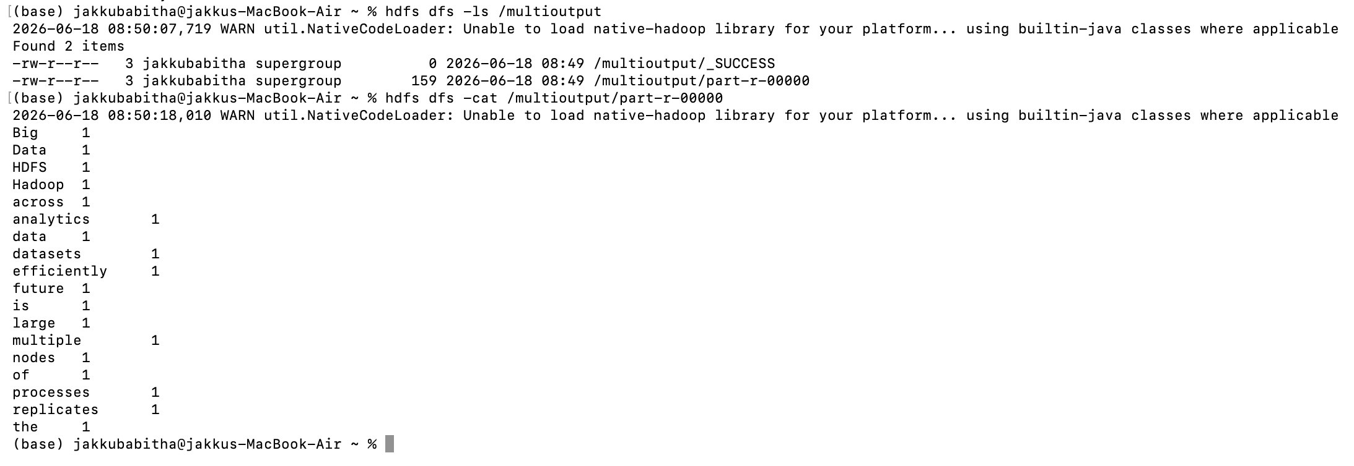
Fig 3: Combined word count output from two input files — 2 items found in /multioutput, words counted across both files
Result
MapReduce successfully processed two files from /multiinput and produced a merged word count in /multioutput/part-r-00000. Words appearing in both files (e.g., 'Big', 'Data', 'Hadoop') were aggregated correctly across all input files.
Conclusion
This experiment confirmed that Hadoop MapReduce can process multiple input files in a single job by pointing to an HDFS directory. Word frequencies were merged across all files, demonstrating Hadoop's ability to handle distributed, multi-source data processing efficiently.

